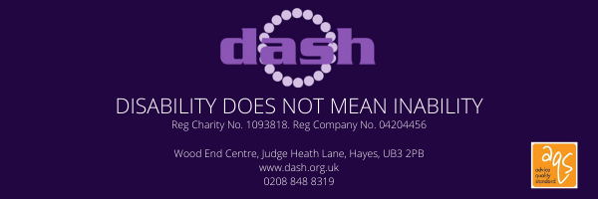

CONTACT DETAILS:
NAME:
TITLE:
ADDRESS:

CONTACT NUMBER:
EMAIL:
D.O.B:
ETHNICITY:
NATURE OF DISABILITY/LONG TERM HEALTH CONDITION:

SUPPORT REQUIRED-PLEASE CIRCLE AS APPROPRIATE
PIP- APPLICATION/REVIEW/MANDATORY RECONSIDERATION/APPEAL
UC- NEW CLAIM/UC50/MANDATORY RECONSIDERATION/APPEAL
FREEDOM PASS
BLUE BADGE
OTHER-PLEASE DETAIL

Please complete form fully, incomplete forms will cause a delay in support being provided.
Please email completed forms to info@dash.org.uk
You will be contacted within 5 working days with an appointment.

